Supplementary figures and tables
Figure 1. LumPAT scoring method (18).
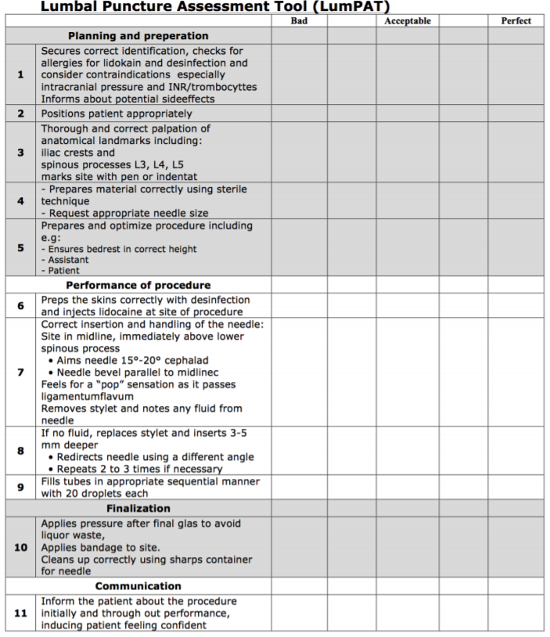

Table 1. Reliability score, adapted from the DISCERN tool (19).
Reliability score
1) Are the aims clear and achieved?
2) Are reliable sources of information used?
3) Is the information presented balanced and unbiased?
4) Are additional sources of information listed for student reference?

Table 2. Global Quality Score (GQS), modified from Singh et al (19).
Global Quality Score (GQS)
1) Poor quality, poor flow, most information missing, not helpful for students.
2) Generally poor, some information given but of limited use to students.
3) Moderate quality, some important information is adequately discussed.
4) Good quality good flow, most relevant information is covered, useful for students.
5) Excellent quality and excellent flow, very useful for students.

Table 3. Attractiveness and Understandability score, adapted from the original PEMAT score (20).
Attractiveness and Understandability (AU)
1) Organization
The video presents the information in a logical sequence.
The video provides a summary or key teaching points in the end.
2) Visual aspects
The video image is clear (sharp image, adequate lighting) and uncluttered.
The video uses visual cues (e.g., arrows, boxes, zooming in) to draw attention to key aspects.
Text on the screen is easy to read.
3) Auditory aspects
The video sound is clear and free from background noise.
The spoken language (instructors or voice over) is understandable (not too fast, not garbled) and can be clearly heard.
The used language is appropriate for biomedical students and junior doctors (correct scientific or clinical terminology).

Table 4. Characteristics of the five best and five worst lumbar puncture videos.
Parameter | The 5 best videos  1) https://www.youtube.com/watch?v=WpXGUn7eGZE  2) https://www.youtube.com/watch?v=S9KKzpJ7Awg  3) https://www.youtube.com/watch?v=YmzDT-LXQPY  4) https://www.youtube.com/watch?v=0K5H7uep8K8  5) https://www.youtube.com/watch?v=QoUGM4wqUU0 | The 5 worst videos  1) https://www.youtube.com/watch?v=O77_UWo0JSc  2) https://www.youtube.com/watch?v=xLaXXupyG4w  3) https://www.youtube.com/watch?v=R2_0gOI8uV0  4) https://www.youtube.com/watch?v=h3XBCaQkPtg  5) https://www.youtube.com/watch?v=I5FwIIv47Xo | P-value
Length of video | 11,00 (8,01) | 3,27 (3,73) | 0,02*
Viewership/day | 52,44 (156,97) | 15,00 (111,76) | 0,25
Likes/day | 0,13 (0,42) | 0,03 (0,06) | 0,18
Dislikes/day | 0,01 (0,05) | 0,01 (0,01) | 0,34
Comment count/day | 0,01 (0,02) | 0,01 (0,02) | 0,53
VPI | 49,44 (140,00) | 12,01 (94,00) | 0,33
LumPAT score | 43,50 (5,50) | 22,50 (5,30) | <0,01*
Reliability score | 3,00 (0,80) | 2,50 (0,80) | 0,03*
GQS | 4,25 (0,88) | 1,63 (0,44) | <0,01*
AU score | 7,00 (1,00) | 4,50 (2,80) | 0,01*
VPI = Video Power Index; GQS = Global Quality Score; AU score = Attractiveness and Understandability score; * indicates a significant p-value

